Brit College of Engineering & Technology (BCET)
https://bcet.uk

Professional Certificate in Business Data Analytics (Introduction Level)


PORTFOLIO DESIGN, IMPLEMENTATION & EVALUATION
TITLE  Mr/Ms/Mrs/Dr | Mr
Full Name | FAYSAL AHMED
DATE OF BIRTH  DD/MM/YYYY | 20/04/1999
Email | 19101043@uap-bd.edu  iamfaysalahmed@gmail.com
WhatsApp No. | +8801776368039

** You must delete the instructions given in the second column of the table below
INTRODUCTION | My name is Faysal Ahmed, and I am currently a student with a strong interest in software development and data analysis. I enjoy learning new technologies and applying them to real-world problems. This assignment reflects my understanding of the topic and my effort to present the analysis clearly and effectively.  Thank you for taking the time to review my work.
RESULTS AND IMPACT  (from POWER BI Desktop) | 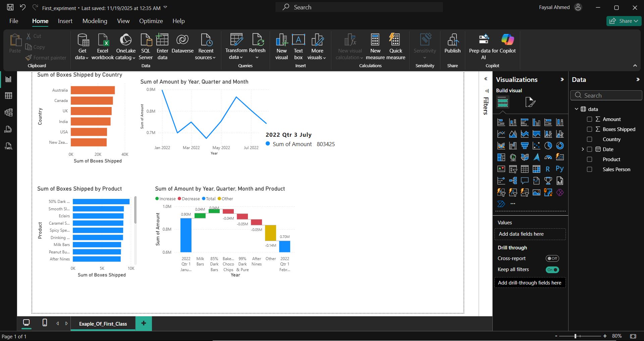  This is my first test on power bi and when I try it at first it was quite complex but in time, I find it very interesting  And it helps me to understand how can I manipulate my data to show the exact screen.
RESULTS AND IMPACT  (from Tableau Desktop) | 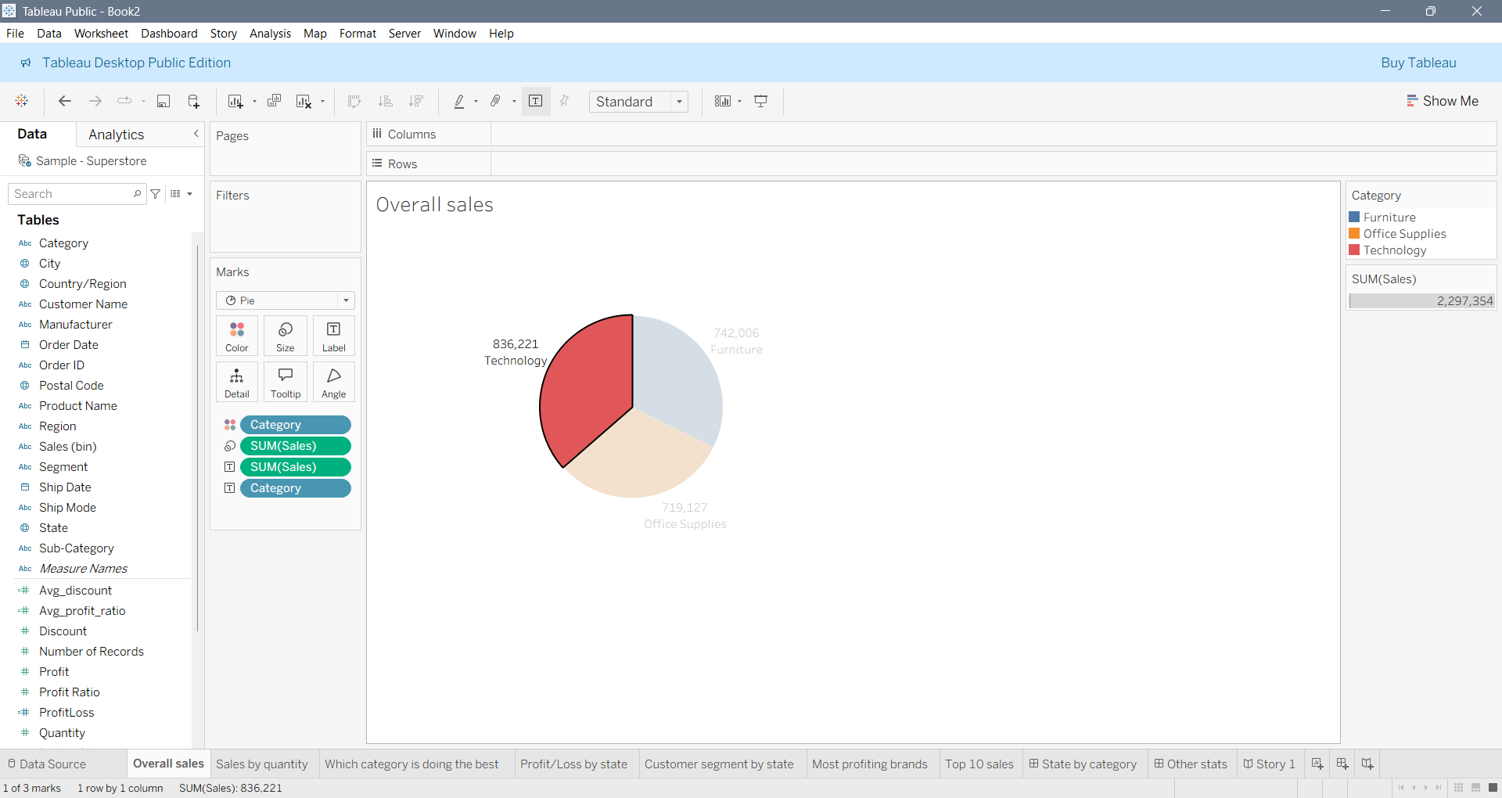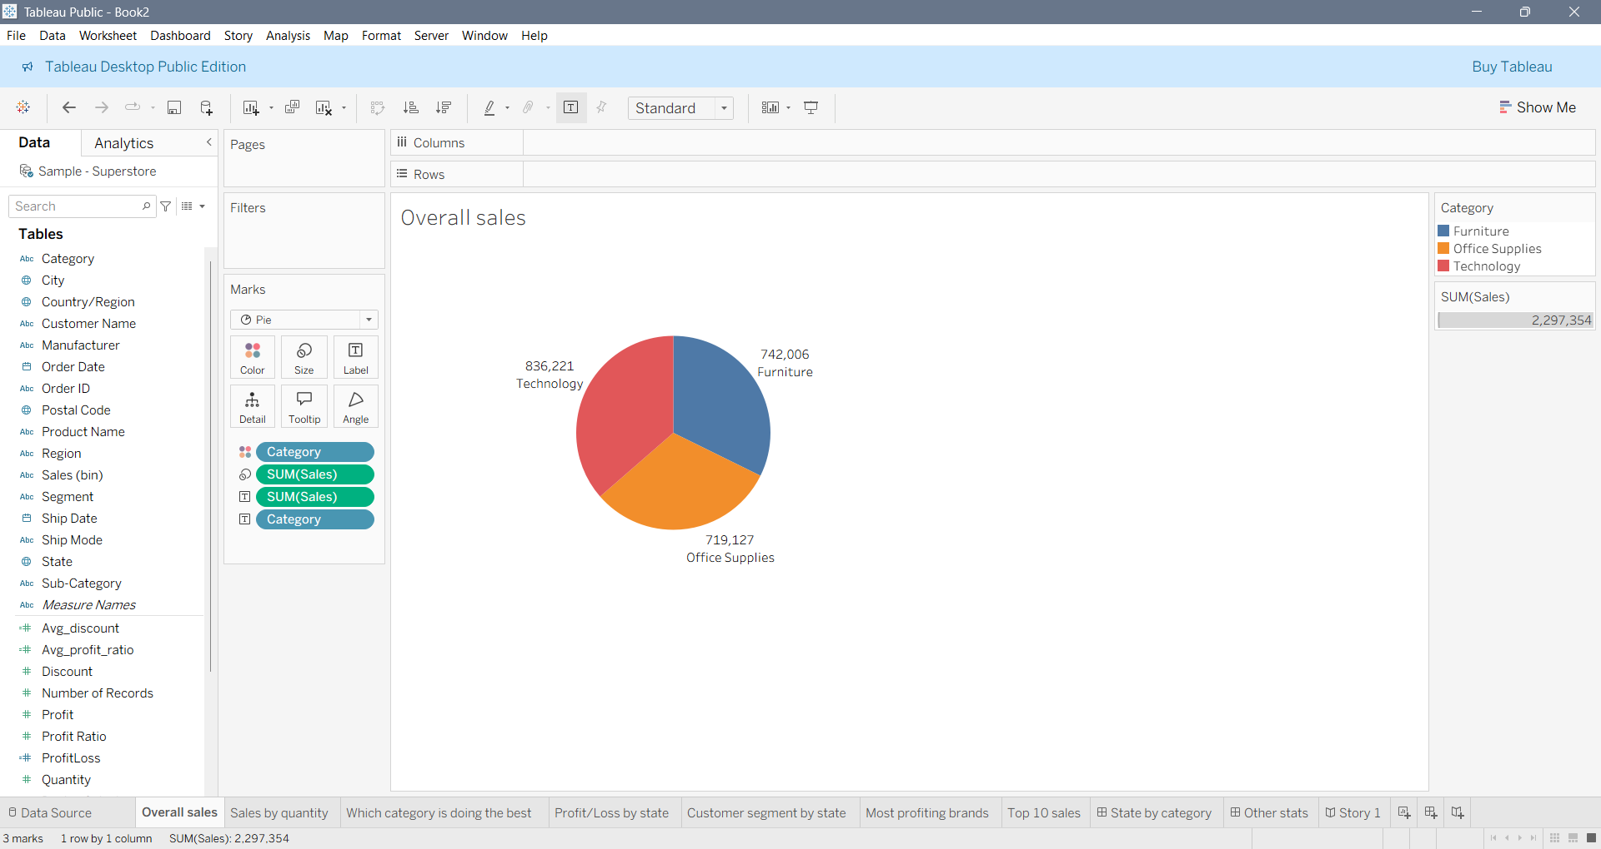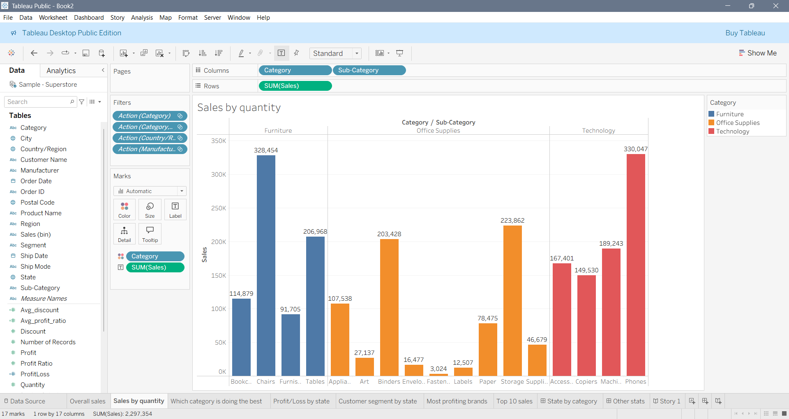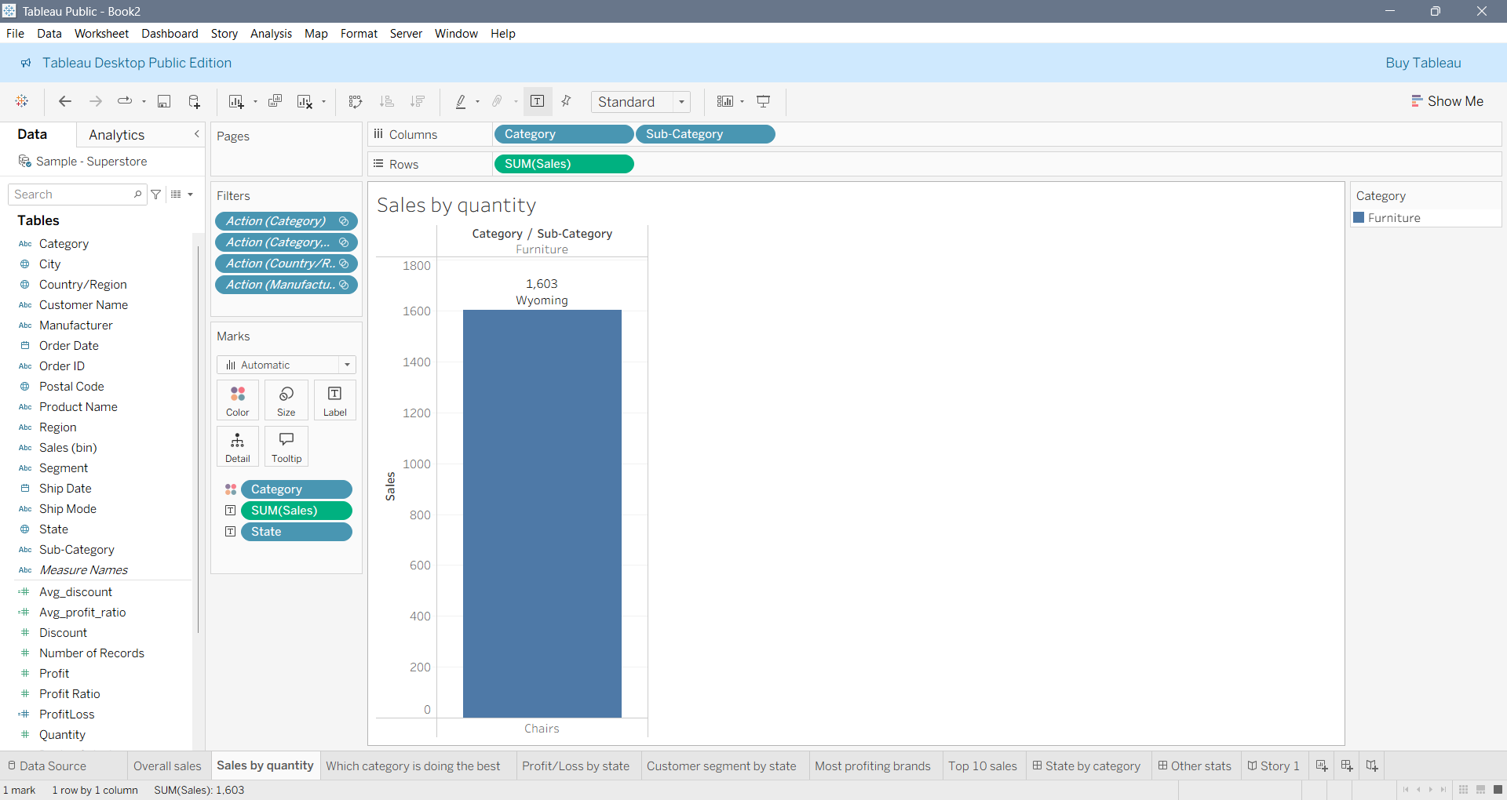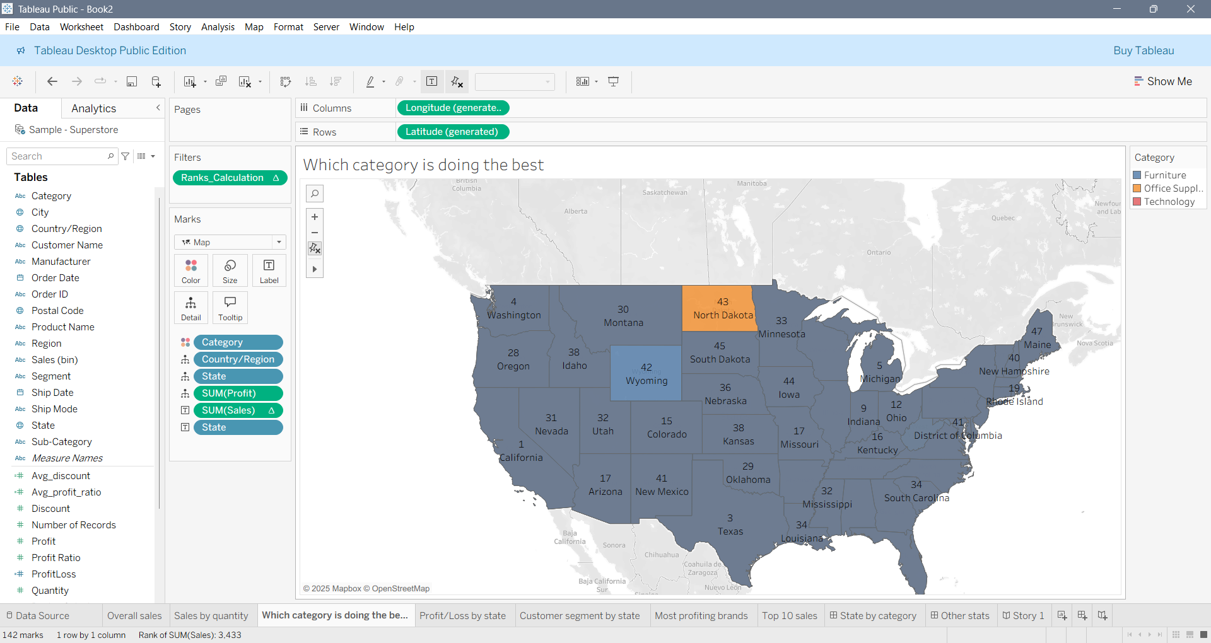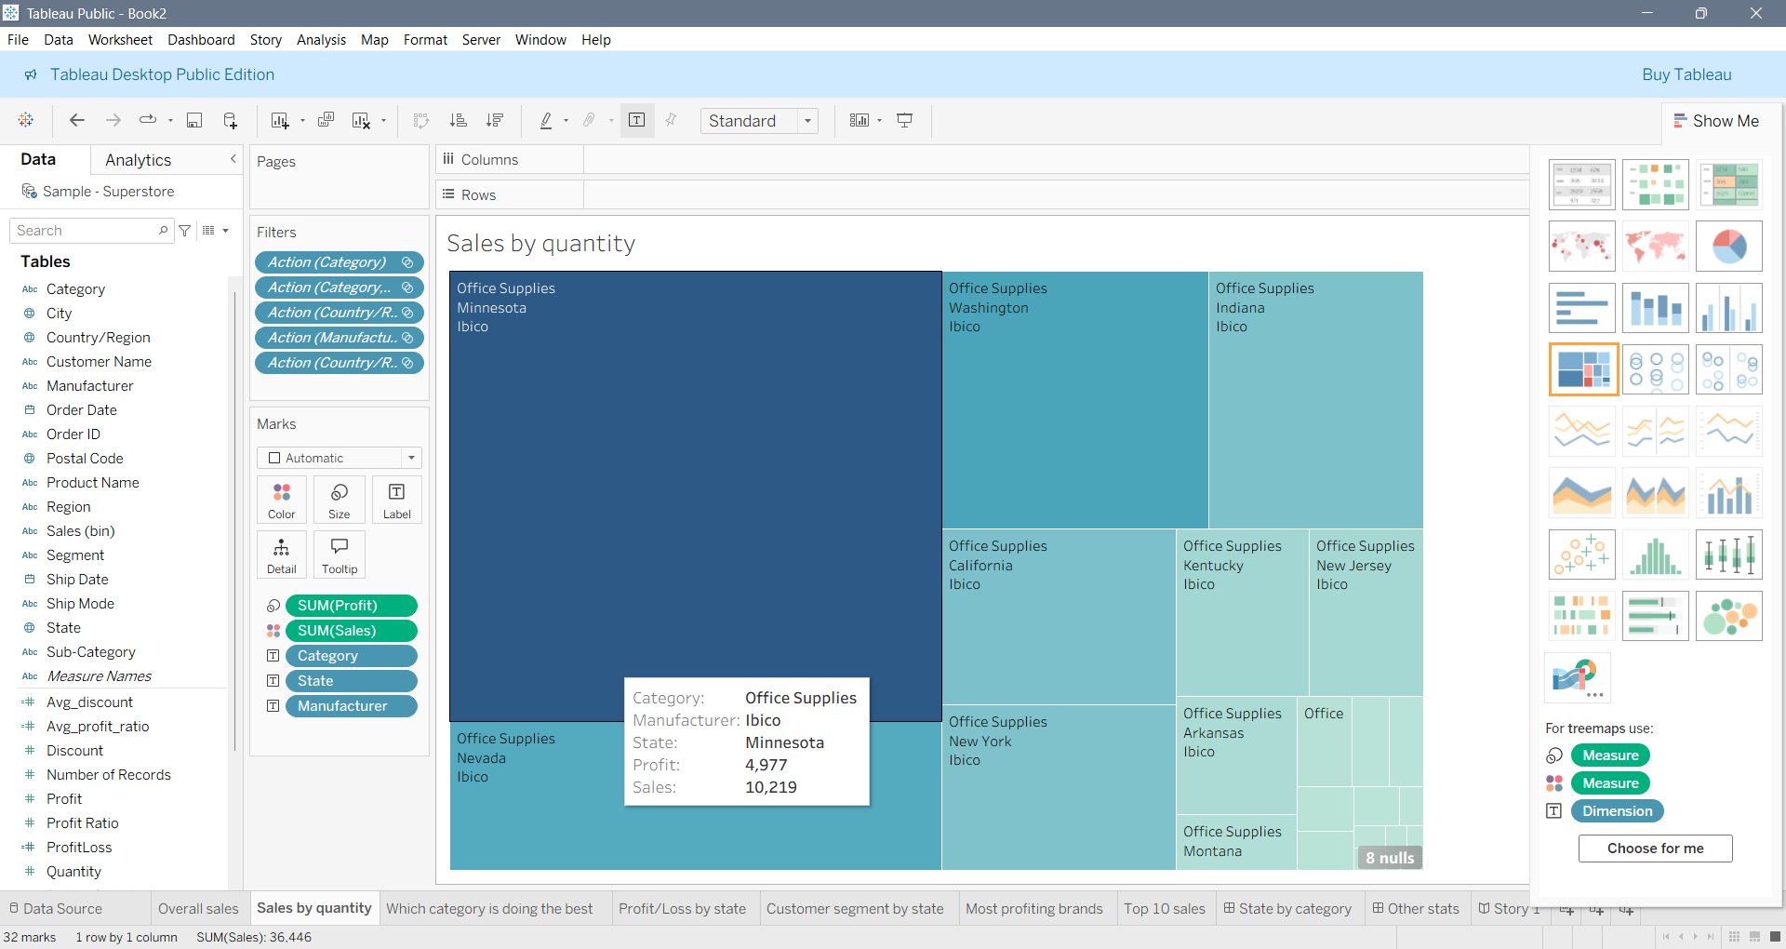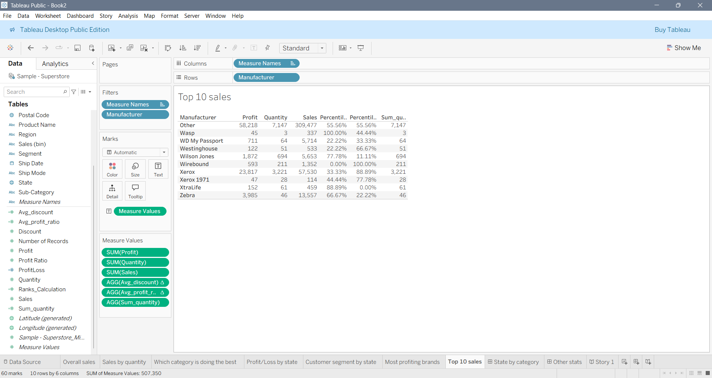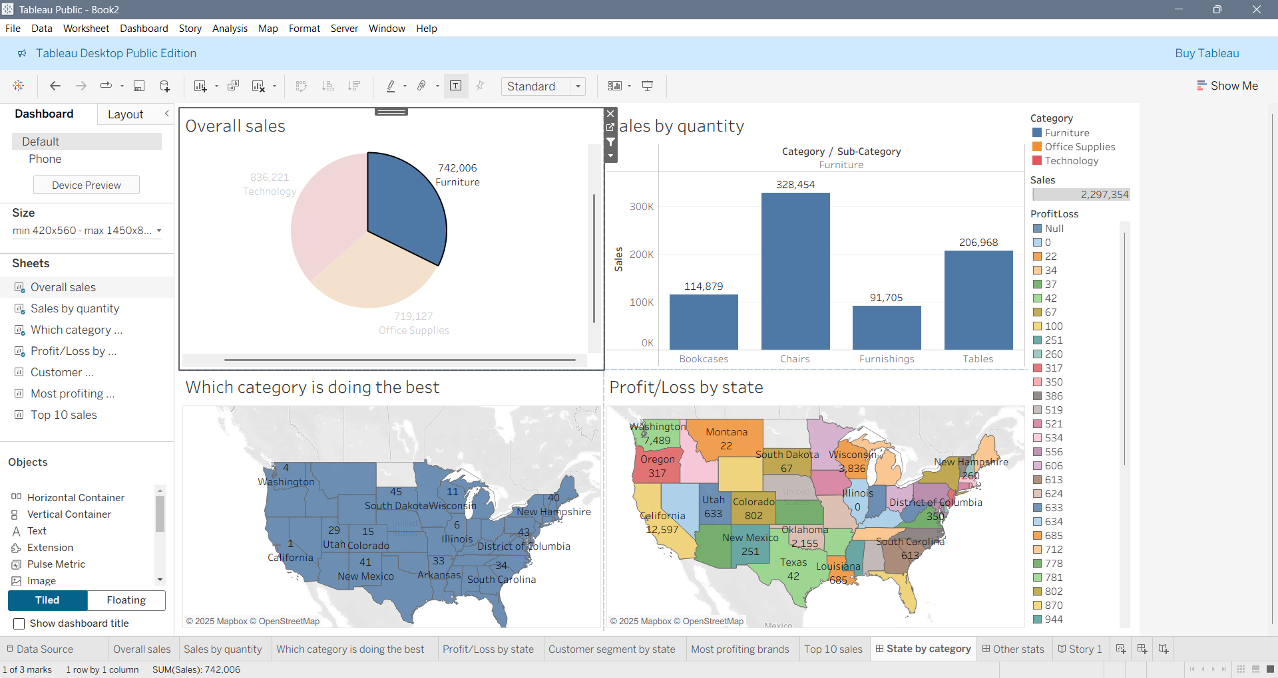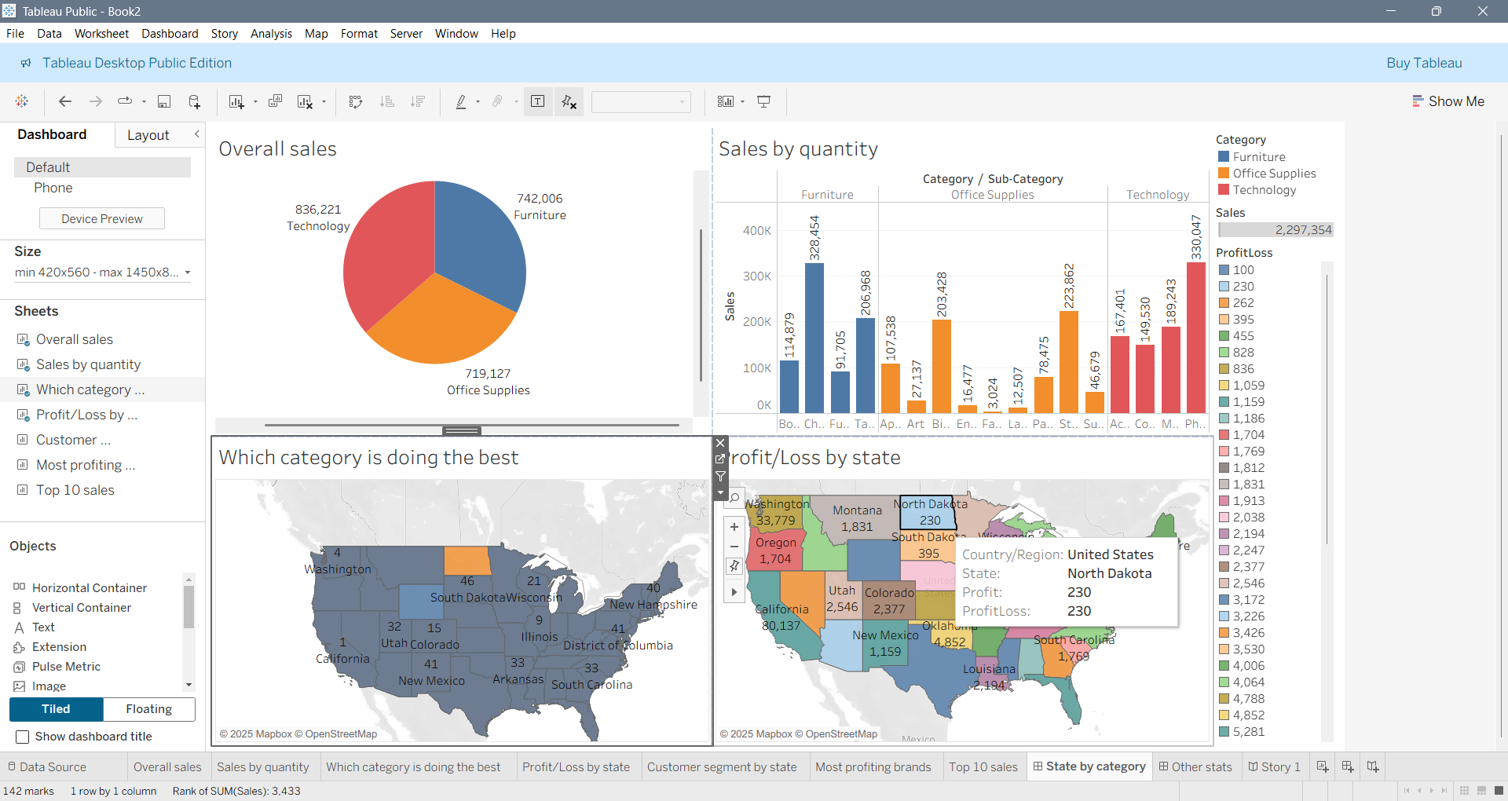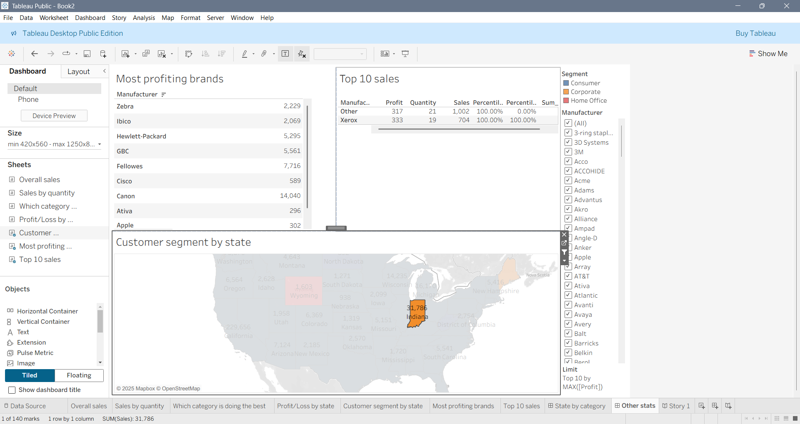  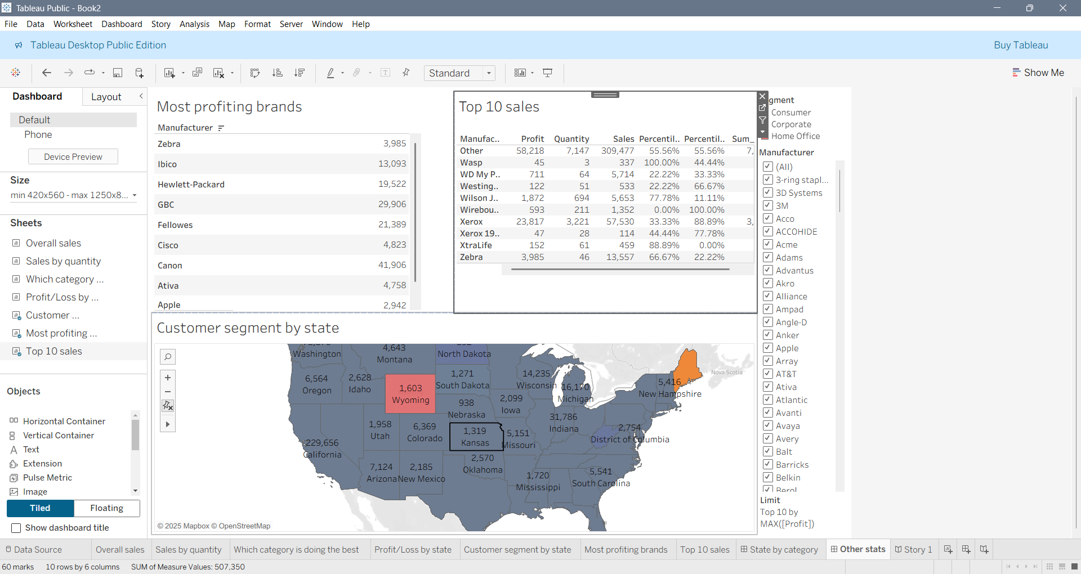
I have done my most work on Tableau and I find it very interesting. It was easy to catch but in other stats I
Have got confused cause when ever I try to select my top listed item it take me to my sales by quantity. And I
Do understand that how my sotry and dashboard work. And I would like to do some more work so that I can
Be prefect on it.
Publishing your work/project in the public domain  [Provide a Tableau link] | Tableau report publish: Superstore_Migrated Data Top sales and overall sales story | Tableau Public
Publishing your work/project in the public domain  [Provide a Power BI link] | Power BI report publish: I try my assignment on Tableau. Please review it.
LinkedIn Profile Link | LinkedIn Profile: (5) Faysal Ahmed | LinkedIn
Medium Profile Link | Medium Profile: https://medium.com/ >> For Blog/Article writing based on your Power BI and Tableau projects  [Help: https://www.youtube.com/watch?v=rLIWnhrXLxY ]
GitHub Profile Link | GitHub Profile: codeshrabon (iFaysal)  Tableau Assignment: codeshrabon/Superstore_Migrated_Data_Top_sales_and_overall_sales_story: Using Tableau to manipulate data to show how they work
GitLab Profile Link | GitLab Profile: https://about.gitlab.com/free-trial/
Conclusions | Over the last three days of the master class, I learned how to work with Tableau and Power BI to convert raw data into meaningful visual insights. I explored how data contains different fields, where Dimensions represent descriptive attributes such as Category, State, and Region, and Measures represent quantifiable values like Sales, Quantity, and Profit.  Using Tableau, I created multiple visualizations, including pie charts, bar charts, maps, and dashboards. I analyzed overall sales, category-wise performance, customer segments, state-level profit and loss, most profitable brands, and top 10 sales performers. I also applied filters, labels, ranks, and custom calculated fields to enhance accuracy and interpretation. Additionally, I understood how geographical fields like latitude and longitude support map-based visualizations.  In Power BI, I learned the difference between loading data directly and transforming data using Power Query for cleaning and manipulation before analysis.  Overall, this assignment helped me understand how to prepare data, choose meaningful visualizations, apply filters and actions, and present results in a clear and interactive way. This experience strengthened my confidence in business intelligence tools and improved my ability to communicate insights through data visualization.

